Git Repo : https://github.com/vishwjeet-ujgare

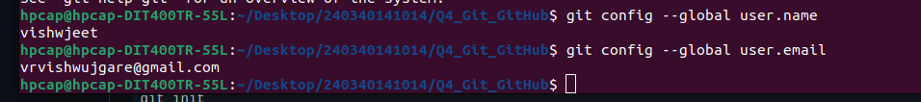
1) Checking git configurations
git config --global user.name
git config --global user.email

2)Access GitHub “lab-exam-repo”
git clone https://github.com/vishwjeet-ujgare/lab-exam-repo.git
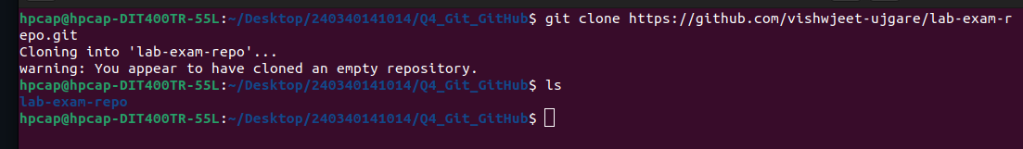
3)Created new file “lab-file.txt”
Do ls into your lab-exam-repo folder i.e repo
created a txt file using vim and added content to it .
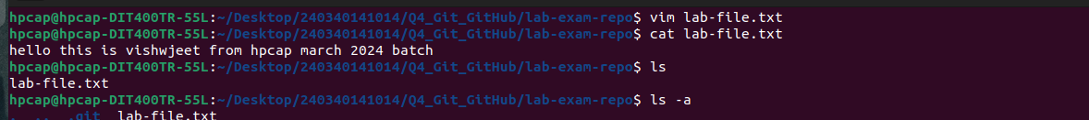

4)add, commit,push
a) file added
git add <file name >: To add perticular file
git add * : To add all file in staging area

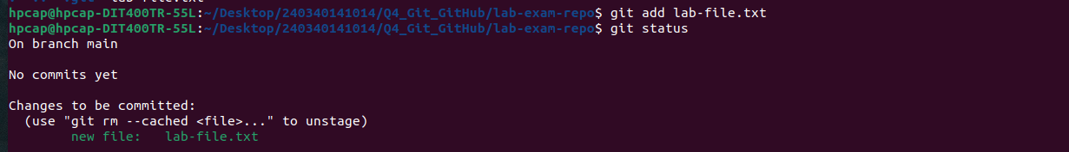
b) Commit
git commit -m “Your msg”

d) push
git push: to push on git hub need to login by entering user name and token of you gitHub account
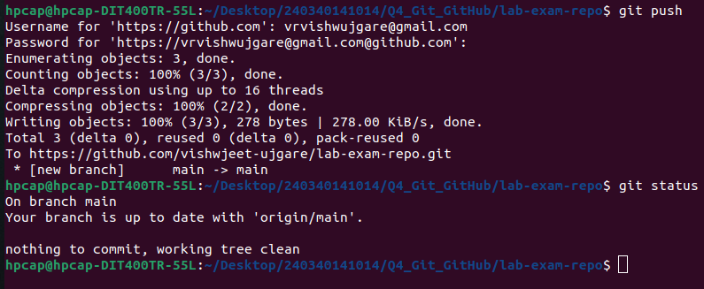

5)Verifying file has pushed succesfully by checking the GitHub Repo
